Home Equity Reverse Mortgage Information Technology
(HERMIT)

HERMIT System Changes – Release 6.81

Release Date: 09/17/22
Document Date: 09/17/22

September 2022

INTRODUCTION
The Home Equity Reverse Mortgage Information Technology (HERMIT) software release version 6.81 consists of the following system changes:
Table of Contents
1. Multi-Factor Authentication added to HERMIT 3
2. The Receivable Type “Repurchase” will no longer display on the Accounting > Authorization page when the loan is Terminated. 4

If you have any questions regarding the functionality of the software release, please contact the HERMIT Help Desk at 561-899-2610 or at servicingsupport@hermitsp.com. If you have any policy related questions, please send an email to HUD at answers@hud.gov.

Multi-Factor Authentication added to HERMIT
In order to gain access to the HERMIT website, Multi-Factor Authentication was added to the HERMIT application as an extra layer of security. When a User attempts to log into HERMIT, the Multi-Factor Authentication Extra Security Step window will be displayed. After selecting the preference of which way to receive the Multi-Factor Authentication Temporary Code, a window will be displayed allowing you to input the code and log into HERMIT.
If the User only has an Email Address on file with HERMIT, the Multi-Factor Authentication Extra Security Step window will state an Email is only on file and they will only be able to receive the Multi-Factor Authentication code via email. If a user wishes to have their mobile/cell phone number listed on file, they will need to call the HERMIT Help Desk.
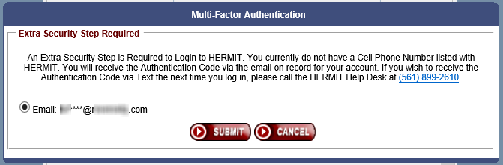

The Multi-Factor Authentication Extra Security Step window will allow the user to select how they would like to receive their Multi-Factor Authentication Code either via email or text if they have the data for both fields recorded in HERMIT.
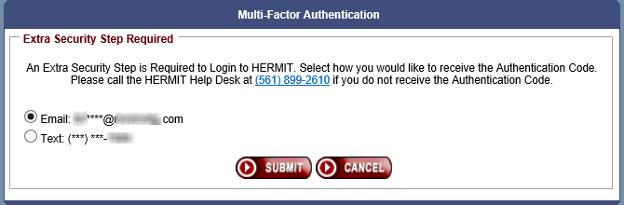

Once the user has selected which way they would like their Multi-Factor Authentication code sent, the user will receive their code either via text or email depending on their selection. The user will then enter this code in the Multi-Factor Authentication Temporary Code window which is displayed after clicking Submit on the Multi-Factor Authentication Extra Security Step window. Once the correct Multi-Factor Authentication Code is input and the user clicks login on the Multi-Factor Authentication Temporary Code window, the HERMIT Home Screen will be displayed, and the user will have access to HERMIT.
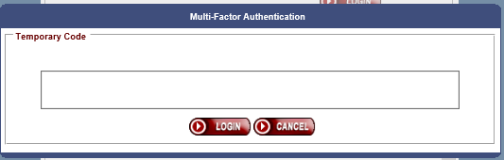

Please Note: The Temporary Code will expire after 5 minutes, and the user will need to attempt to login to HERMIT again to receive another code. After three failed attempts of inputting the incorrect code the user’s account will be locked and the user will need to reset their password under the HERMIT login screen.

The Receivable Type “Repurchase” will no longer display on the Accounting > Authorization page when the loan is Terminated.
- Once the loan has been Terminated the user will no longer be allowed to see the loan with Receivable Type “Repurchase” under the Accounting > Authorization page. Therefore, this prevents the user from Authorizing a Repurchase on a Terminated loan.

